ERM and DFA using

Active Knowledge Structures

Presented by

Jim Brander

Interactive Engineering Pty Ltd

www.inteng.com.au

Goals

Correlation/dependency: The storing of correlations and dependencies
Integration: Methodology for integrating correlated risk distributions into models
Dependency/causal models: The modeling of risk defined by presumed causes

Active Structure

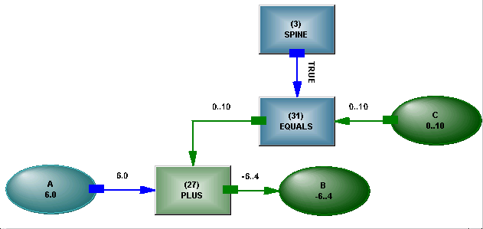
This example of structure is for the humble equation A + B = C
Some considerable differences can already be seen – the EQUALS is implemented, and there is a logical control signal coming from a SPINE. The spine provides a logical surface on which the statements are written. The arrows show the current direction of information flow in the structure. The green color indicates a range is being propagated, while blue indicates a singular value and yellow, not shown here, indicates no value known.

The term Active Structure indicates that activity occurs within the structure – operators respond to activity on their connections by producing outputs, which may overlie inputs. There is no external algorithm which performs these operations. Adding structure may cause the phasing of operations to change as a result of the altered topology.

A Logical Example

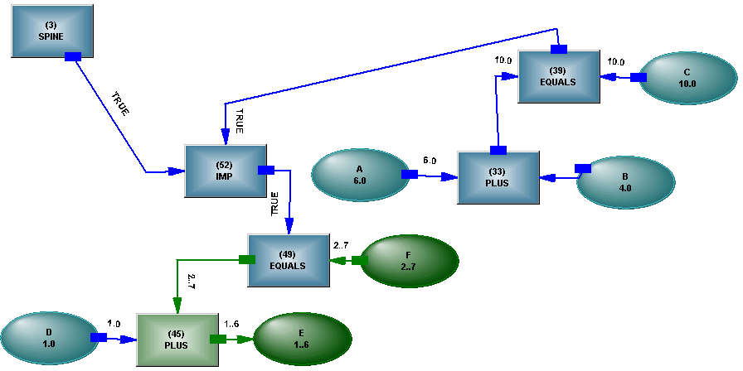
The statement IF A + B = C THEN D + E = F

Note how the two EQUALS operators are identical except for the direction of information flow. IF..THEN is implemented as a logical implication. This means that Modus Tollens applies, not particularly significant here, but relevant when there are ranges on the antecedent.

Self – Modification

If the structure were simply static, the effect would be rather boring, necessitating much work on the part of the user to change it. The operators in the structure can change the structure around them. A simple example is

A = SUM(List)

SUM implies an operation, but until we know how many members are in the list, we can’t connect to them. The initial form is
When the members of the list are known, an operator connects them to the PLUS operator that implements the summation.
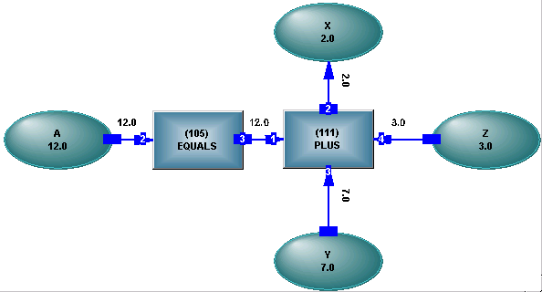

In keeping with an uncommitted structure, the structure is actually working out a value for X.

If the value for the list changes – the members change or are no longer known - the structure goes back to its original state and waits for a new list value.

While it is trivial here, the self-modification of the topology allows the structure to increase its connections and hence the ability to hold states in response to values propagated through it.

Each of the mathematical operators and programming operations has a structural analog – SIGMA or a FOR loop for instance, where changes of state mirror the flow of control in a program. By realizing the analysis completely as structure through which values are propagated, each part of it becomes visible to every other part and its phasing is trivial.

Depending on the operator, information can flow in any direction in any part of the structure, and can flow bi-directionally while consistency is maintained. This property is exploited for handling stochastic information.

Distributions and Correlations

It is desirable to integrate stochastic information with analytic structure. A distribution can be held in the following structure

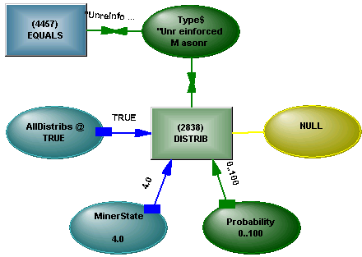

The operator has controls which turn it on and off, and control which state it is in – quiescent, learning or running. The distribution can be read in from a file or can be produced by activating the variable using data mining – if in Learn mode, the operator will build a distribution depending on how many times the variable has been activated with a specific value. The distribution is held in a sparse form – by using discontiguous ranges, nothing is held where there are no occurrences. When switched to Run mode, the operator makes the distribution available at the variable by reversing the information flow in the link to the variable.

Correlations are held in a similar structure

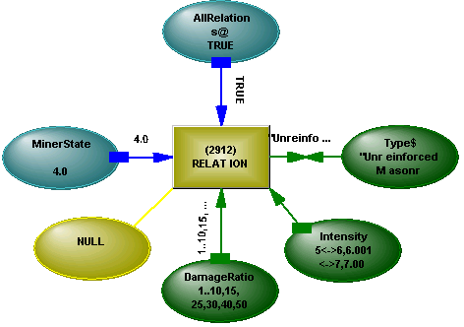
The details of the correlation are entered from a file, calculated from distributions or built using activation. A change in range at one variable will cause a change in distribution at the others.

Integration of Stochastic Information

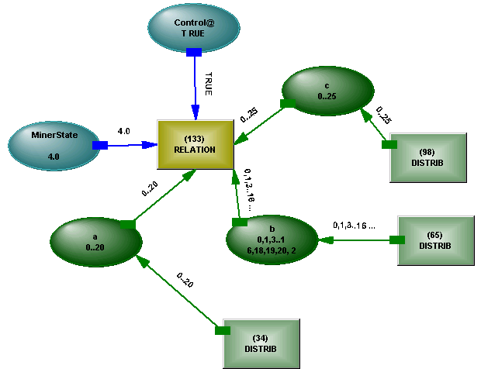
The combination of distributions and relations results in a stochastic representation which is closely analogous to the A + B = C analytic structure. There is the same logical control and the same undirected nature.

Simulation

The limitations of the single value method of analysis are touched on. The worth of many thousands of simulation runs is commented on, in the context of a learning element. The same distribution and correlation structures that hold stochastic information for simulation can also be embedded in the simulation model, learning to avoid less than felicitous outcomes.

Event – Driven Risk Analysis

The structure can be used to represent events in both a logical and time sense. Real events can spawn hypothetical events which in turn spawn other events, and it is the interaction of all of the events that gives rise to the calculation of risk of a catastrophic event occurring.

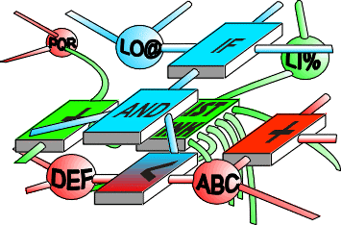Meeting the Goals

We are suggesting the conference goals of
- Correlation/dependency
- Integration
- Dependency/causal models
can be met by using an active uncommitted long-lived self-modifying structure propagating complex messages.

