REINVENTING RISK CLASSIFICATION

A SET THEORY APPROACH*

BY
ROMEL SALAM


CAS Ratemaking Seminar

March 2002

RISK CLASSIFICATION FOR ACTUARIES

How should actuaries be grouped?

- Based on area of practice (life vs non-life) and years of experience (10 or fewer vs 11 or more).

- Based on actuary’s eyewear (bifocals vs contact lenses) and on whether actuary is left-handed or right-handed.

Resulting groupings will be referred to as cells.

Questions

- What is the purpose of grouping the risks in the first place?
- How do we know a given grouping scheme works?
- Is there an ideal or optimal grouping scheme?
- Simply put, what is Risk Classification or its purpose?

Answers: We begin our search for answers in the CAS’s vast library on the subject.
Two papers captured the essence of the current thinking on the subject:

The Academy’s definition

“ …[process of] grouping risks with similar risk characteristics for the purpose of setting prices…”

“Risk Classification is intended simply to group individual risks having reasonably similar expectations of loss”

Finger’s definition

“…formulation of different premiums for the same coverage based on group characteristics”

Let’s review these answers in the context of our heuristic example for classifying actuaries:

First, a couple of informal but intuitive definitions:

- Two cells are said to be compatible if they have similar loss propensity.
- Two cells are said to be incompatible if they have dissimilar loss propensity

SCENARIO 1

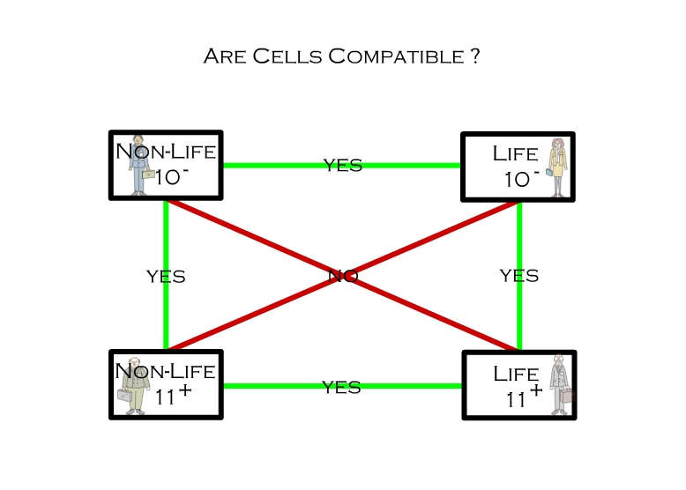
This scenario fits the Academy’s definition but what have we accomplished?
Not sure this scenario fits Finger’s definition since we should not be able to formulate different premiums for the different cells.

SCENARIO 2
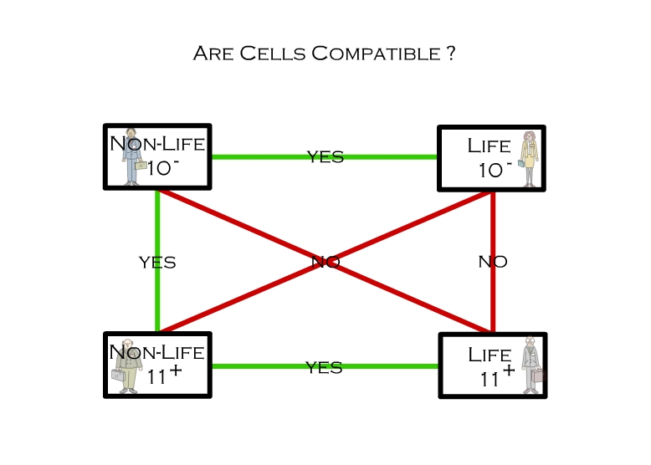
Again, this scenario fits the Academy’s definition but what have we accomplished?
Not sure what Finger would say.
SCENARIO 3
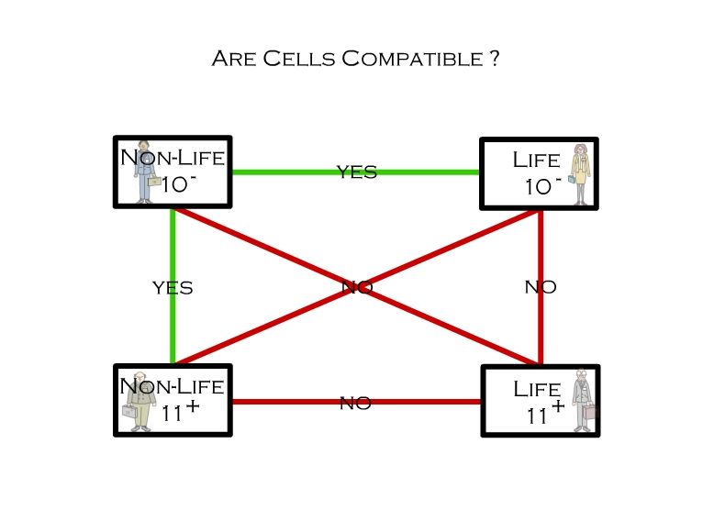
This scenario also fits the Academy’s definition but what have we accomplished?
Not sure what Finger would say.

SCENARIO 4
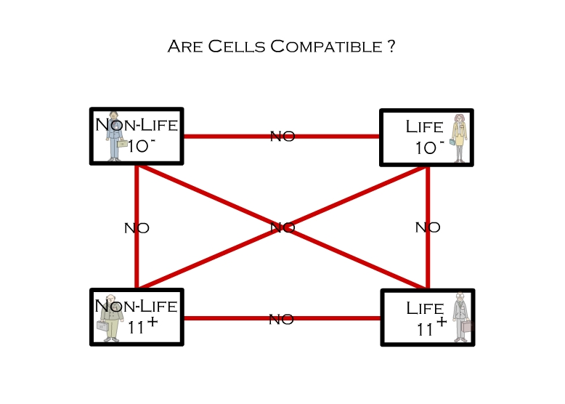
Is this the only scenario in which we can say the scheme has been successful?

An exercise in hypothesis testing:

Hypothesis 1: Homogeneity: Actuaries within the same cell have the same loss propensity.

Generally, we’ll assume this hypothesis to be true until proven false. If, for instance, grouping non-life actuaries into pension and P&C results in groups with distinct loss propensities, then homogeneity assumption is false.

Hypothesis 2: Separation: Actuaries within different cells have
Have different loss propensities.

This hypothesis is tested by successively pairing cells.

How do we handle these scenarios?

In scenario 1, the scheme falls completely apart. The separation hypothesis is false.

An alternative classification scheme is provided by dropping one of the rating variables. For instance, by dropping the years of experience variable, we would compare Life versus Non-Life actuaries

In scenario 4, the scheme holds. The separation hypothesis holds.

In that scenario, the parameters underlying the probability model for life actuaries with 10 or fewer years of experience would be estimated based solely on the experience of that cell. The same would apply to the remaining three cells.

In scenarios 2 and 3, the scheme does not hold nor does it fall apart completely.

In the second scenario, the estimates of the parameters of the models of all four cells would involve other cells

In the third scenario, the estimates of the parameters of the models of all four cells would involve other cells except those for life actuaries with more than 11 years of experience.

Defining Risk Classification

Risk: “Individual or entity covered by financial security systems.

Risk Characteristic: Attribute that identifies a risk or group of risks.

Classification Variable: Categorization or set of risk characteristics consisting of two or more such characteristics. Within a classification variable, risk characteristics define mutually exclusive sets of risks. In other words, a risk can’t be identified by more than one characteristic within a classification variable.

Classification Dimension: Number of classification variables used.

Classification Cell: Set of risks sharing all the same risk characteristics.

Adjacent Cells: Two cells $C_{j}$and $C_{k}$are adjacent if they have exactly D-1 common characteristics where D represents the dimension of the classification scheme.

Alternate Definition: Two cells $C_{j}$and $C_{k}$are adjacent if they have at least 1 common characteristic.

Cell Universe Ω: Set of all cells defined by the classification variables and risk characteristics.

Compatibility: $C_{k}$ is compatible with $C_{j}$ if there is a “reasonable probability” that the observations in cell$C_{k}$could have come from the a priori model (or from a model with the same parameters as) for cell $C_{j}$. By definition, a cell is compatible with itself.

Incompatibility: $C_{k}$ is incompatible with $C_{j}$ if $C_{k}$ is not compatible with $C_{j}$. By definition, we will require that non-adjacent cells be incompatible with one another.

Relation R from Ω to Ω: Non-empty set of ordered pairs $(C_{j},C_{k})$such that $C_{k}$ is compatible with $C_{j}$. If $(C_{j},C_{k})∈R$, we write$C_{k}{\text{RC}}_{j}$. If$(C_{j},C_{k})∉R$, we write$C_{k}RC_{j}$. If two cells $C_{j}$and $C_{k}$are non-adjacent, then by definition $C_{k}RC_{j}$and $C_{j}RC_{k}$

Properties of Equivalence Relations:

1) Reflexivity:



2) Symmetry:


3) Transitivity:
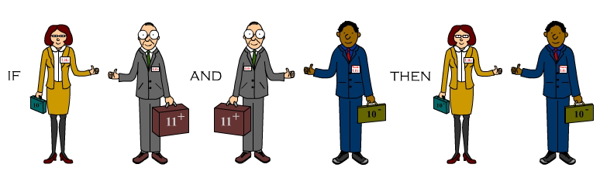

By definition, the first property always holds for the compatibility relation R from Ω to Ω. However, Compatibility need be neither symmetric nor transitive. In order words, Compatibility need not be an equivalence relation. In Appendix D, we provide an example of an asymmetric relation.
Class$\left\{C_{j}\right\}$: Set of all cells that are compatible with $C_{j}$. All cells$C_{k}∈Ω$ s.t. $(C_{j},C_{k})∈R$. Each cell within a classification scheme defines its own class.


Credibility: Weights assigned to the a priori parameter estimates of the cells in a class $\left\{C_{j}\right\}$in order to come up with the a posteriori parameter estimates for the cell $C_{j}$.

- The Academy, Finger, McClenahan, and many others use credibility as almost a synonym for confidence.

- Venter, Philbrick tell us this definition is misleading if it implies that the credibility weight is an inherent property of the data. They define credibility as the appropriate weight to be given to a statistic of the experience in question relative to other experience.


An example

Let’s use an expanded version of the classification example presented in our introduction to illustrate our definitions:

Classification Variables and Risk Characteristics: Area of practice (life, pension, P&C), Years of experience (10 or fewer, 11 or more), Geographical Location (West Coast, East Coast).

Classification Dimension: 3.

Adjacent Cells: Using the first definition, two cells are adjacent if they have two common characteristics.

Model:
$$f(x)=\frac{(λd)^{x}e^{−λd}}{x!}$$

Compatibility: $C_{k}{\text{RC}}_{j}$if $\text{Pr}\text{ob}(λ_{j}=λ_{k})≥\text{.}9$.

Basic Data (See first three columns of Summary Table on last page)

MLE Estimates (See Initial MLE Estimate in Summary Table on last page)
Recall the two hypotheses introduced in the discussion above.
1) Actuaries within the same cell share the same loss propensity.
2) Actuaries across different cells have different loss propensities.
$${\hat{R}}_{0}=\frac{{\hat{λ}}_{j}−{\hat{λ}}_{k}}{\sqrt{\frac{{\hat{λ}}_{j}}{d_{j}}+\frac{{\hat{λ}}_{k}}{d_{k}}}}$$
If $λ_{j} \text{and} λ_{k}$are equal (we will refer to the equality of the$λ$’s as a sub-hypothesis) in which case we will say that cells $C_{j}$and $C_{k}$are compatible, then${\hat{R}}_{0}→N(0,1)$.

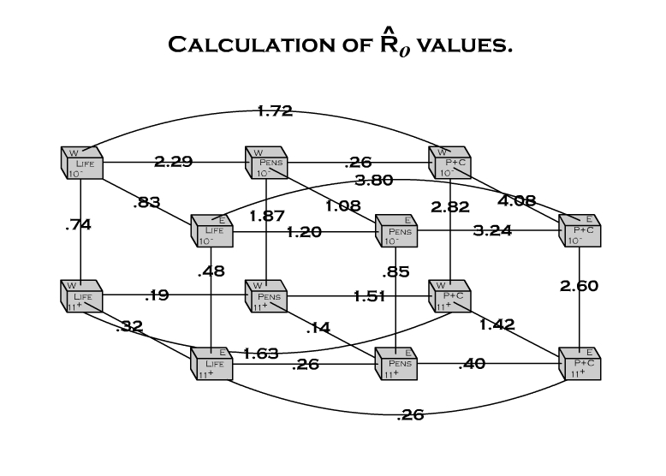

Reject or accept Sub-hypothesis that actuaries across pairs of cells have different loss propensities?
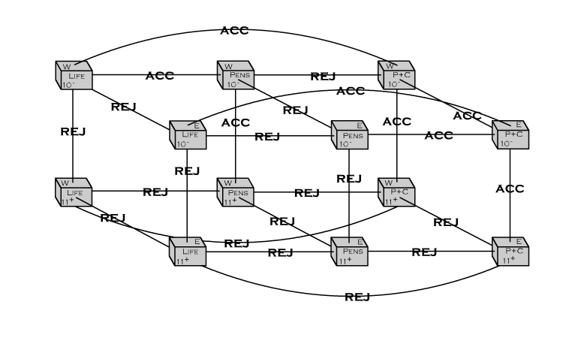

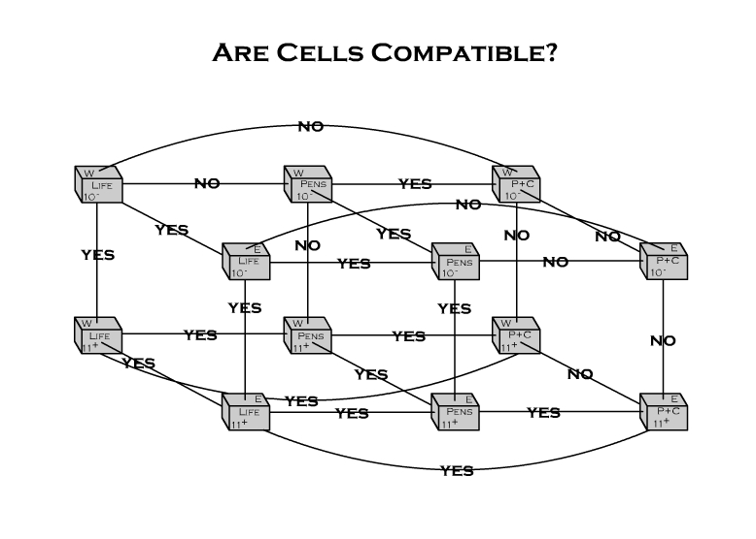

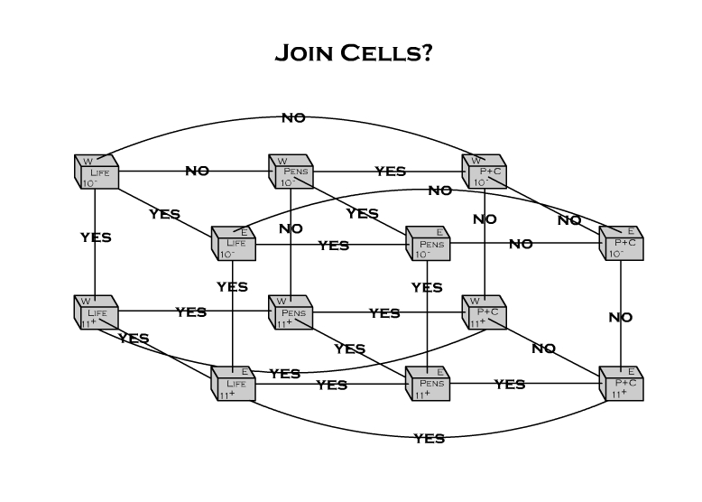

Classes:
Life_10⁻E | Life_10⁻E | Life_11⁺ E | Life_10⁻W | Pension_10⁻ E
Life_11⁺ E | Life_11⁺ E | Life_10⁻E | Life_11⁺ W | Pension_11⁺ E | P&C_11⁺ E
Pension_10⁻ E | Pension_10⁻ E | Pension_11⁺ E | Pension_10⁻ W | Life_10⁻E
Pension_11⁺ E | Pension_11⁺ E | Pension_10⁻ E | Life_11⁺ E | Pension_11⁺ W | P&C_11⁺ E
P&C_10⁻ E | P&C_10⁻ E
P&C_11⁺ E | P&C_11⁺ E | P&C_11⁺ W | Pension_11⁺ E | Life_11⁺ E
Life_10⁻W | Life_10⁻W | Life_10⁻E | Life_11⁺ W
Life_11⁺ W | Life_11⁺ W | Life_11⁺ E | Life_10⁻W | Pension_11⁺ W | P&C_11⁺ W
Pension_10⁻ W | Pension_10⁻ W | Life_10⁻W | Pension_11⁺ W | Pension_10⁻ E
Pension_11⁺ W | Pension_11⁺ W | Life_11⁺ W | P&C_11⁺ W | Pension_11⁺ E
P&C_10⁻ W | P&C_10⁻ W | Pension_10⁻ W
P&C_11⁺ W | P&C_11⁺ W | Pension_11⁺ W | P&C_11⁺ E | Life_11⁺ W

Credibility :
Life_10⁻E | Life_10⁻E  .21 | Life_11⁺ E  .30 | Life_10⁻W  .34 | Pension_10⁻ E  .15
Life_11⁺ E | Life_11⁺ E  .23 | Life_10⁻E  .16 | Life_11⁺ W  .39 | Pension_11⁺ E  .18 | P&C_11⁺ E  .05
Pension_10⁻ E | Pension_10⁻ E  .17 | Pension_11⁺ E  .27 | Pension_10⁻ W  .32 | Life_10⁻E  .24
Pension_11⁺ E | Pension_11⁺ E  .22 | Pension_10⁻ E  .14 | Life_11⁺ E  .29 | Pension_11⁺ W  .29 | P&C_11⁺ E  .06
P&C_10⁻ E | P&C_10⁻ E  1.00
P&C_11⁺ E | P&C_11⁺ E  .10 | P&C_11⁺ W  .08 | Pension_11⁺ E  .36 | Life_11⁺ E  .46
Life_10⁻W | Life_10⁻W  .32 | Life_10⁻E  .20 | Life_11⁺ W  .48
Life_11⁺ W | Life_11⁺ W  .34 | Life_11⁺ E  .20 | Life_10⁻W  .23 | Pension_11⁺ W  .20 | P&C_11⁺ W  .03
Pension_10⁻ W | Pension_10⁻ W  .26 | Life_10⁻W  .32 | Pension_11⁺ W  .28 | Pension_10⁻ E  .14
Pension_11⁺ W | Pension_11⁺ W  .27 | Life_11⁺ W  .47 | P&C_11⁺ W  .05 | Pension_11⁺ E  .21
P&C_10⁻ W | P&C_10⁻ W  .24 | Pension_10⁻ W  .76
P&C_11⁺ W | P&C_11⁺ W  .06 | Pension_11⁺ W  .32 | P&C_11⁺ E  .07 | Life_11⁺ W  .55

Revised MLE Estimates (See Revised MLE Estimate 1 Summary Table on last page)

Validation
- Validation helps us decide whether the chosen model will be relevant or valid in some future period for which a forecast is sought.

- Randomly selecting out of each cell a percentage of the observations, say 90%, and re-estimate the parameters of the cells through the same process used for the full data set.

- “train and test” and those based on “bootstrap” may be adapted to our classification problem.
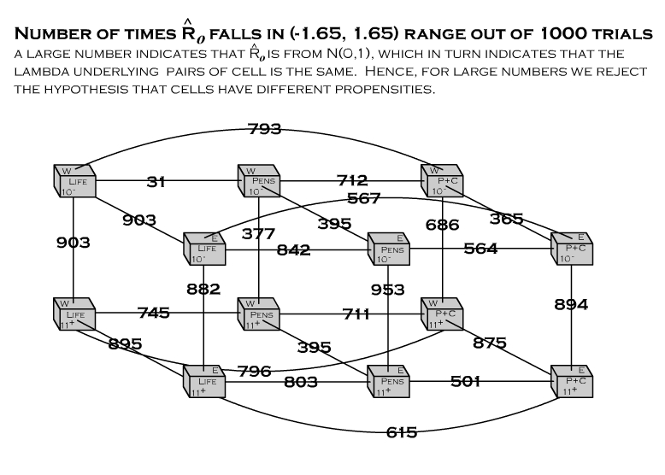

Reject or accept Sub-hypothesis that actuaries across pairs of
cells have different loss propensities?

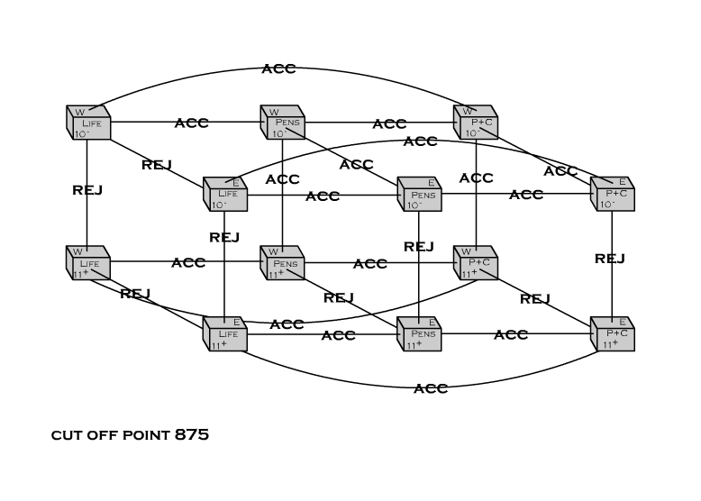

Classes after Validation
Life_10⁻E | Life_10⁻E | Life_11⁺ E | Life_10⁻W
Life_11⁺ E | Life_11⁺ E | Life_10⁻E | Life_11⁺ W
Pension_10⁻ E | Pension_10⁻ E | Pension_11⁺ E
Pension_11⁺ E | Pension_11⁺ E | Pension_10⁻ E | Pension_11⁺ W
P&C_10⁻ E | P&C_10⁻ E | P&C_11⁺ E
P&C_11⁺ E | P&C_11⁺ E | P&C_10⁻ E | P&C_11⁺ W
Life_10⁻W | Life_10⁻W | Life_11⁺ W | Life_10⁻E
Life_11⁺ W | Life_11⁺ W | Life_11⁺ E | Life_10⁻W
Pension_10⁻ W | Pension_10⁻ W
Pension_11⁺ W | Pension_11⁺ W | Pension_11⁺ E
P&C_10⁻ W | P&C_10⁻ W
P&C_11⁺ W | P&C_11⁺ W | P&C_11⁺ E

Credibility after Validation
Life_10⁻E | Life_10⁻E  .25 | Life_11⁺ E  .35 | Life_10⁻W  .40
Life_11⁺ E | Life_11⁺ E  .29 | Life_10⁻E  .21 | Life_11⁺ W  .50
Pension_10⁻ E | Pension_10⁻ E  .39 | Pension_11⁺ E  .61
Pension_11⁺ E | Pension_11⁺ E  .34 | Pension_10⁻ E  .22 | Pension_11⁺ W  .44
P&C_10⁻ E | P&C_10⁻ E  .67 | P&C_11⁺ E  .33
P&C_11⁺ E | P&C_11⁺ E  .26 | P&C_10⁻ E  .53 | P&C_11⁺ W  .21
Life_10⁻W | Life_10⁻W  .32 | Life_11⁺ W  .48 | Life_10⁻E  .20
Life_11⁺ W | Life_11⁺ W  .44 | Life_11⁺ E  .26 | Life_10⁻W  .30
Pension_10⁻ W | Pension_10⁻ W  1.00
Pension_11⁺ W | Pension_11⁺ W  .56 | Pension_11⁺ E  .44
P&C_10⁻ W | P&C_10⁻ W  1.00
P&C_11⁺ W | P&C_11⁺ W  .44 | P&C_11⁺ E  .56

MLE estimates after Validation (See Revised MLE Estimate 2 in Summary Table on last page)

Classification Efficiency

- Robert Finger defines it as: “a measure of a classification system’s accuracy [6, p.250].” “A perfect classification system,” Finger adds, “would produce the same variability as the insured population.
- Finger uses ratio of Coefficient of Variation CV
- Bailey uses similar definition and measure of efficiency.
- Traditional measures of goodness-of-fit may be more appropriate to evaluate the fit of the assumed distribution vis-à-vis the empirical sample distribution. Two measures immediately come to mind: the Chi Square and the Kolmogorov-Smirnov statistics.
- “Efficiency is a measure of a classification system’s relative accuracy.”

Practical Considerations
- The claim process may be decomposed into a frequency and severity component and these components can be further decomposed into more sub-components.
- If adjustments are made to the data, the model needs to be adjusted accordingly.
- Some tests may not work when sample size is small. Use simulated distributions.

Areas of development
- Various tests and statistics need to be developed in order to make inferences about other distributions, such as the Gamma, Pareto, or the Negative Binomial, that are often used in insurance problems.
- Non-parametric approaches to hypothesis testing such as those based on “bootstrap” and “permutation.”
- Handling continuous risk characteristics such as age?

Some common questions

- How practical is this approach?

We have used it for a real life three-dimensional classification scheme.
Yes, it can apply to more complex problems involving higher dimensions and a larger number of risk characteristics.
Since rules are well defined, they should be easily programmable.

- Is this approach doing away with good old sacrosanct actuarial judgment?

Not in the least. Variables and characteristics, significance levels, compatibility definitions are all the actuary’s creation. However, the actuary’s initial judgment is put to test against evidence whose rules he/she him/herself has defined.

What have we done?

- Reviewed the common definitions of Risk Classification.

- Established a more rigorous and consistent treatment of the subject by borrowing terminology from Set Theory.

- Defined more rigorously such concepts as homogeneity and separation and integrated them into the very definition of Risk Classification.

- Launched one more assault on the notion, pervasive still in parts of our literature, of Credibility as a synonym for Confidence.

- Provide an alternative to using arithmetic functions (i.e. relativities, principle of balance, base class) in Risk Classification problems.

- Propose measures for assessing the relative efficiency of competing schemes.

- Suggest procedures for validating a classification scheme.

Summary Table

Actuaries | Exposure  Units | # of Claims | Initial  MLE Estimate | Revised MLE Estimate 1 | Revised MLE Estimate 2 | Actual  λ
Life_10⁻E | 5,000 | 24 | .0048 | .0057 | .0055 | .0050
Life_11⁺ E | 7,000 | 38 | .0054 | .0052 | .0051 | .0050
Pension_10⁻ E | 3,500 | 24 | .0069 | .0066 | .0058 | .0060
Pension_11⁺ E | 5,500 | 28 | .0051 | .0056 | .0056 | .0060
P&C_10⁻ E | 3,000 | 2 | .0007 | .0007 | .0024 | .0030
P&C_11⁺ E | 1,500 | 9 | .0060 | .0051 | .0025 | .0030
Life_10⁻W | 8,000 | 47 | .0059 | .0053 | .0053 | .0050
Life_11⁺ W | 12,000 | 61 | .0051 | .0053 | .0054 | .0050
Pension_10⁻ W | 6,500 | 60 | .0092 | .0067 | .0092 | .0100
Pension_11⁺ W | 7,000 | 37 | .0053 | .0050 | .0052 | .0060
P&C_10⁻ W | 2,000 | 20 | .0100 | .0094 | .0100 | .0070
P&C_11⁺ W | 1,200 | 3 | .0025 | .0051 | .0044 | .0040

