Discussion of THE “MODIFIED BORNHUETTER-FERGUSON” APPROACH TO IBNR ALLOCATION

By Glenn Walker

PRESENTED TO CASUALTY ACTUARIAL SOCIETY

NOVEMBER 14, 2005
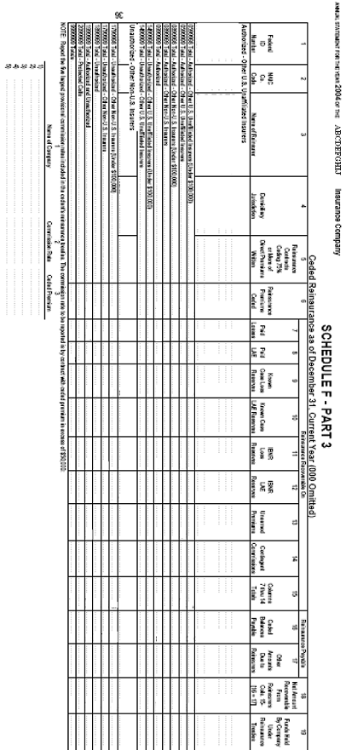

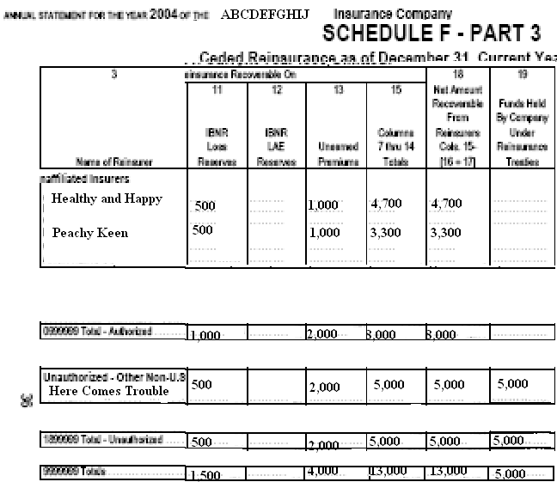

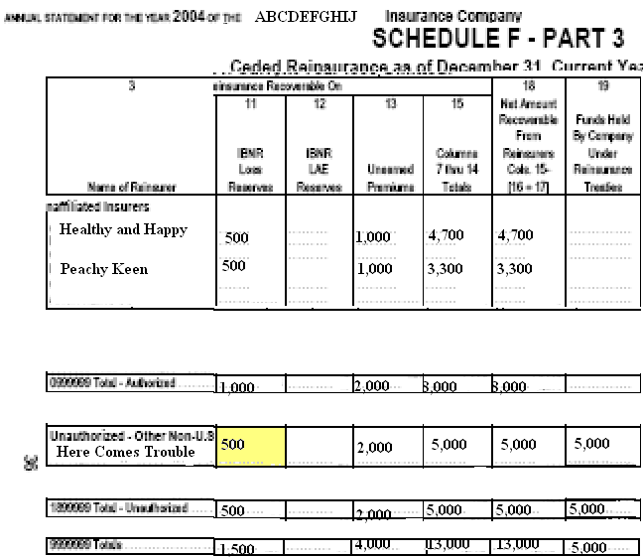
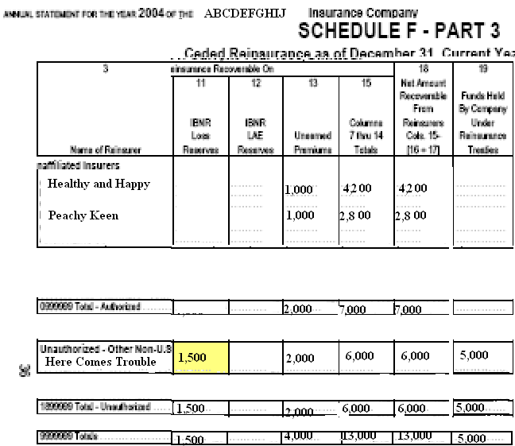
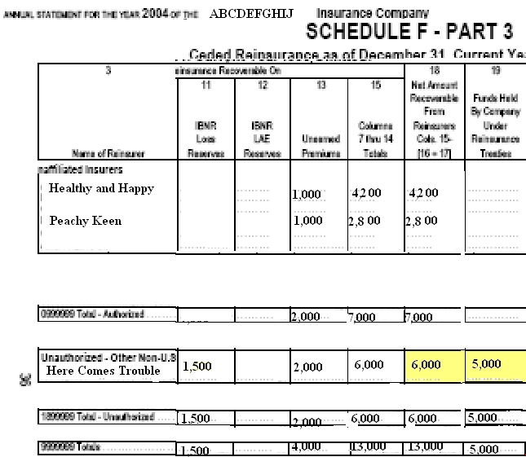
ALLOCATION OF IBNR TO REINSURER IS NOT A PROLEM IF:

- Single Reinsurer

- Quota Share Only

- Separate Ceded Analyses are possible
ALLOCATION OF IBNR TO REINSURER IS A MANAGEABLE PROLEM IF:

- Separate Reinsurers cover Individual Levels of Reserve Analysis

- Separate Reinsurers cover different periods of time

But for most companies with a comprehensive reinsurance program, the entries onto Schedule F result from some manner of allocation process.

The fact that the Company involved the Actuary in that allocation process is likely a step up from most companies.
For security to function as intended, the amount of security a Company holds should not be a function of any particular Ceded IBNR allocation methodology, but rather should be a function of Probable Maximum Ceded amount reinsurer by reinsurer.
ALLOCATION OF IBNR TO REINSURER IS NOT A PROLEM IF:

- Single Reinsurer

- Quota Share Only

- Separate Ceded Analyses are possible

ILLOGICAL EXTREME

- Two unauthorized reinsurers: Each reinsure one building facultatively @ 100% for $1,000,000

- The company knows that one of the buildings has burned down. There is no information on which one.

- Add $1,000,000 to Direct and Ceded reserves.

- How should Ceded Reserves be Allocated to Reinsurer?

- How much security should be demanded from each reinsurer?
CEDED IBNR ALLOCATION

- Pro: Sum of all reinsurers balances to company total

- Con: Guarantees inadequate security for some reinsurers

PML IBNR ALLOCATION

- Pro: Better assures that security is adequate when required

- Con: Total ceded IBNR is excessive, leading to inadequate Net Reserves.

- Con: Reinsurers are not financially able to post PML security client by client.
SINGLE REINSURER USING PML

But even at 100% allocation, the security can prove inadequate; reinsurance collectibility, though fully secured, is not assured; and the methodology of Ceded IBNR allocation is not at fault.

It may be a challenge for the Company to obtain the security beyond that implied by a Ceded IBNR allocation. But the difference between the aggregate Probable Maximum Ceded and the aggregate Ceded IBNR is simply the amount of adverse reserve development that the Company is exposed to arising from possible Ceded IBNR misallocation.
Difficulties with a PML Ceded Methodology

- the burden on the Actuary to calculate it

- the burden on the Company to obtain higher security

- and the burden on the reinsurer to commit additional funds to this new standard

But the burden of adverse reserve development arising from a Ceded IBNR misallocation to a troubled reinsurer can be significant as well.

