The CAS in 2015
Celebrating our Past, Focused on the Future

Jessica Leong
Midwestern Actuarial Forum
Chicago, IL March 20, 2015

CAS.

We like to do things together

2

CAS Vision - A

X will be recognized globally as the premier organization in advancing the practice and application of actuarial science.

3

CAS Vision - B

To make X members recognized leaders in the management of risk and contingent events.

4

CAS Vision - C

We will serve the public interest by ensuring that where there is uncertainty of future financial outcomes, actuaries are trusted

and | sought after | for | their | valued | analysis
and | authority.

5

CAS Vision

The CAS will be recognized globally as the premier organization in advancing the practice and application of casualty actuarial science and educating professionals in general insurance, including property &
casualty and similar risk exposures.

6

Basic education
Continuing education Research Professionalism

Outreach

Basic education
Continuing education Research Professionalism

Outreach

Strategy: Basic Education

More: Statistics Technology Communications

9

Basic Education: Statistics

New Exam S (Statistics and Probabilistic Models)

– Replaces Exam ST, Exam LC, and VEE Statistics

– 4-hour multiple choice exam

– offered in Fall 2015

10

Basic Education: Technology

Admissions Technology Task Force

– candidates to take exams in more real-life situations

11

Basic Education: Technology

Admissions Technology Task Force

– candidates to take exams in more real-life situations

Question: how about open book exams?

12

Basic Education:
Communication

Surveyed 800+ students

20 phone interviews

13

CAS Strategic Plan

Basic education
Continuing education Research Professionalism

Outreach

Strategy: Continuing
Education

More involvement of non U.S.-based actuaries
– Webinar: International Property & Casualty Markets & Benchmarking

More technology
– Wi-fi at conferences + CAS app

More partnerships in content delivery
– UCAS online courses on discipline & predictive modeling

15

Strategy: Continuing
Education

More involvement of non U.S.-based actuaries
– Webinar: International Property & Casualty Markets & Benchmarking

More technology
– Wi-fi at conferences + CAS app

More partnerships in content delivery
– UCAS online courses on discipline & predictive modeling

16

Strategy: Continuing
Education

More involvement of non U.S.-based actuaries
– Webinar: International Property & Casualty Markets & Benchmarking

More technology
– Wi-fi at conferences + CAS app

More partnerships in content delivery
– UCAS online courses on discipline & predictive modeling

17

Strategy: Continuing
Education

More involvement of non U.S.-based actuaries
– Webinar: International Property & Casualty Markets & Benchmarking

More technology
– Wi-fi at conferences + CAS app

More partnerships in content delivery
– UCAS online courses on discipline & predictive modeling

18

Strategy: Continuing
Education

More involvement of non U.S.-based actuaries
– Webinar: International Property & Casualty Markets & Benchmarking

More technology
– Wi-fi at conferences + CAS app

More partnerships in content delivery
– UCAS online courses on discipline & predictive modeling

Question: how do we make the UCAS courses more popular?

19

CAS Strategic Plan

Basic education
Continuing education Research Professionalism

Outreach

Strategy: Research

Variance papers

21

Strategy: Research

Variance papers

Call papers

22

Strategy: Research

Variance papers

Call papers

Sponsored papers

23

Strategy: Research

Variance papers

Call papers

Sponsored papers

Papers by research committees

24

Strategy: Research

Variance papers

Call papers

Sponsored papers

Papers by research committees

Papers by academics

25

Strategy: Research

Variance papers

Call papers

Sponsored papers

Papers by research committees

Papers by academics

Excel templates

26

KickStarter for CAS Research

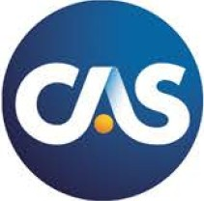
27

KickStarter for CAS Research

Long term accuracy of reserv’g techniques
(4 votes)

)

28

KickStarter for CAS Research

Long term accuracy of reserv’g techniques
(4 votes)

Ranges of reasonable reserve estimates
(7 votes)

votes)

29

KickStarter for CAS Research

Long term accuracy of reserv’g techniques
(4 votes)

Ranges of reasonable reserve estimates
(7 votes)

Are WC mortality models more accurate? (1 vote)

(6 votes)

30

KickStarter for CAS Research

Long term accuracy of reserv’g techniques
(4 votes)

Ranges of reasonable reserve estimates
(7 votes)

Are WC mortality models more accurate? (1 vote)

How do we evaluate cyber risk? (6 votes)

31

KickStarter for CAS Research

Long term accuracy of reserv’g techniques
(4 votes)

Ranges of reasonable reserve estimates
(7 votes)

Are WC mortality models more accurate? (1 vote)

How do we evaluate cyber risk? (6 votes)

32

Automated Vehicles Task Force

33

CAS Strategic Plan

Basic education
Continuing education Research Professionalism

Outreach

CE: Summary of the Academy
Basic Requirements

30 hours per year overall
All hours must meet the “relevant” definition
At least 3 hours of the 30 hours in professionalism
At least 6 in “organized activity”
At least 15 hours directly in your practice area

CAS Strategic Plan

Basic education
Continuing education Research Professionalism

Outreach

Strategy: Influence and
Outreach

Students

Academics

Employers

37

• Study Tools

• Career Resources

Learn About Excrbng New Conten t and Resources on CAS Student Central in the New Future Focus Blog Post. ow.ly/CckSd

CAS Student 1Or<

Reg1ster f or November
E xams P and FME by
Join Us Puzzler

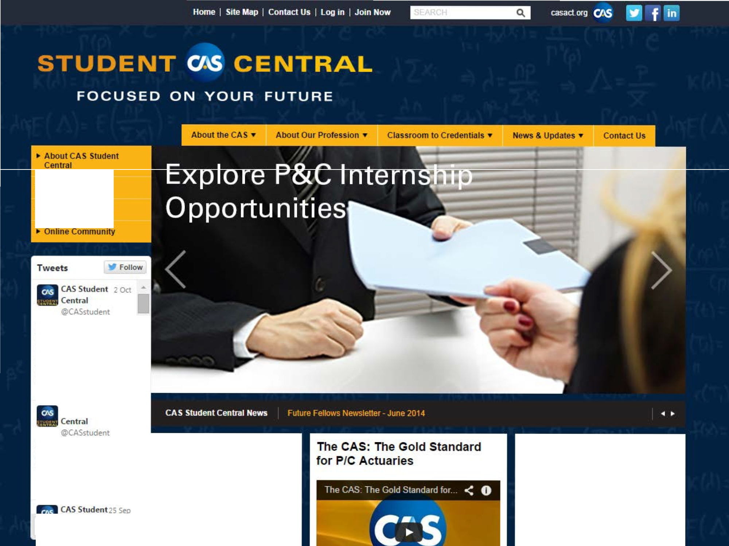
October 2nd. ow.ly'Ca2GL

Tweet to @CASstudent
CAS Student Centralis a membership program for university students interested in pursuing an actuarial career. Join the commumty of
students from nearly 200 universrbes who have already joined this free membership program and gam access to:

Find a new brain twister here every month. We'llpost a variety of puzzles that challenge your mind, stretch your thmking and hone your problem-solving skills.

Check out this month s puzzler and submit your solutions to CASstudentCentral@casact.org.

CAS Student Central

Zhen Qin October 15, 2014 12:47 PM Hello everyone! I'm a new student in Actuarial Science. Since my major in undergraduate is not related to
Insurance, so I've no idea about basic knowledge of
actuarial science so far. So what kind of books or other materials should I read in order to know more about this field? Thank you very much!

- 39 -

CAS Student Central

Voon Seng Lai, FCAS December 4, 2014 12:51 PM I think a useful textbook to get you started will be "Introduction to Risk Management and Insurance" by
Dorfman. You can pick up a copy used …for less than $10.

…If you want to get more into P&C insurance, I would recommend the Foundations by CAS. http://www.casact.org/pubs/index.cfm?fa=castext

And if you just want to keep up with the insurance industry
… there's always the Insurance Information Institute.

http://www.iii.org/
- 40 -

University Liaison Program

University Liaisons support universities by: Making campus visits and presentations to students and faculty
Talking with students on an individual basis

Advising faculty on curriculum

Serving on an Advisory Board at the university

Advising the universities on CAS opportunities, educational system, and materials available

Encouraging attendance at CAS functions

349 CAS members supporting 310 schools.

41

Academic Central

Membership is free to academics teaching actuarial science or related courses

Membership Benefits include:

• Private online community for P/C insights

• Access to resources including the CAS Curriculum
Guide and Case Studies

• Attendance at CAS meetings and seminars with registration fees waived (3 each year)

• Receipt of CAS publications

• Complimentary CAS webinars

249 academic members from 156 schools.

42

CAS Case Studies
Resources for Academics and Students

Case Study Topics:

– Probability

– Catastrophe Modeling

– Warranties

– Liabilities

– Auto Insurance
Case Studies come with Facilitator’s Guide, Presentation Slides, Recording, and Excel
Workbook

43

Employers

On-site Meetings with Large Employers

Towers Watson

Munich Re The Hartford Travelers CNA
Allstate

Liberty Mutual

Question: Have you been involved? Any feedback?

44

“I hope that we can all reach out to each
other and work together to achieve our dreams as Actuaries”

– Eric Entrup, 2014

Questions and Discussion

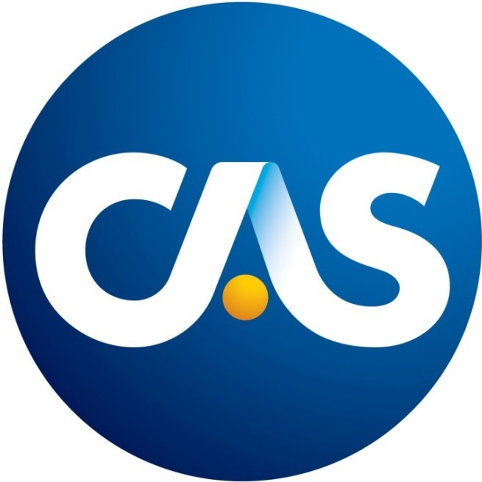

100 Years of Expertise, Insight & Solutions

